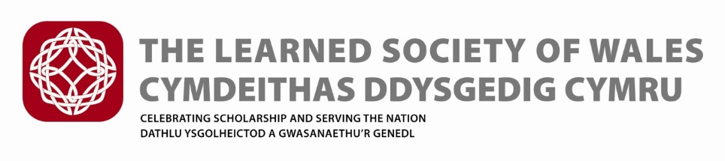
The Frances Hoggan Medal
Revised Regulations (February 2022)
The Award (medal and £500 prize money) is sponsored by the Welsh Government.

The award is named in honour of Dr Frances Hoggan (née Morgan) (1843 –1927), from Brecon, the first British woman to receive a medical doctorate from a university in Europe. The first award was be made in 2015/16.

The award is made to support the promotion and recognition of women engaged in research in science, medicine, engineering or mathematics. The Secretariat secured agreement from members of Hoggan’s family.
The Frances Hoggan Medal of the Learned Society of Wales will be awarded annually in recognition of an outstanding contribution to research in any area of Science, Technology, Engineering, Mathematics and Medicine (STEMM) research, by a woman, resident in Wales or of Welsh birth or who otherwise can demonstrate a particular connection with Wales.
The recipient should be a woman actively engaged in research in the public or private sector or in industry. The research should be based in a scientific, technological, engineering, mathematics or medical discipline, including the scientific aspects of subjects such as geography and archaeology.

- Nomination Process
- Fellows and individuals from universities, industry and the general public will be invited to submit nominations between 1st March and 30th June each year. Assessment will be carried out in July and August with winners announced in September.
- The Committee shall be free to consider persons other than those nominated.
- Nominations must come from individuals (not institutions, companies or organisations) and will need to be supported by two seconding proposers
- Nomination forms will available from the LSW website
- Forms should be submitted electronically and in accordance with the guidance for the year.
- Sufficient information must be provided for reasoned judgements to be made
- It is the nominator’s responsibility to provide adequate information on the form
- Incomplete forms will not be considered
- Unsuccessful nominations Are welcome to resubmit nominations in subsequent years on the appropriate forms.
- The nomination must be kept confidential between the Nominee, the Proposers and the Society

- Exclusions

The following are excluded from making nominations and being nominated:
- LSW medal Committee members
- Institutions, Organisations and Companies [proposers and nominees must be individuals].

- The Committee

- The Medal shall be awarded to the person deemed to be the most worthy by a Committee comprising:
- One Fellow appointed by the General Purposes Committee who shall Chair the Committee;
- Two further Fellows (STEMM) appointed by the General Purposes Committee;
- At least two members of the Committee shall be female.
- Members shall serve for a term of three years, or such shorter period as the Society may decide. They will be eligible to serve for not more than two consecutive terms, following which a further period of three years shall elapse before any such member shall be eligible for re-appointment.
- The Committee may co-opt or consult further Fellows of the Society as required.
- The Committee may conduct its business through meetings or by correspondence.
- The Committee shall reach its decision on the award of the Medal at a time previous to the award ceremony to be held in September of the same year.
- The Medal shall be awarded to one person during each Year but, in the event that the Committee concludes that no person meets the appropriate standard of excellence during a particular year, a Medal shall not be awarded.
- The recipient will be awarded a specially struck commemorative medal and is expected to receive the Award in person at a ceremony. The Medal shall be normally presented by the President of the Society during a ceremony arranged by the Society in September.
- Each medal will be accompanied by a monetary prize and an LSW certificate which will also include the sponsor’s logo.
- Recipients will be invited to deliver a relevant public lecture and/or publish a short article that could be used to raise the profile of women in STEMM in Wales and the UK normally within 12 months of the Award and the Society will support the medallist to do this.

