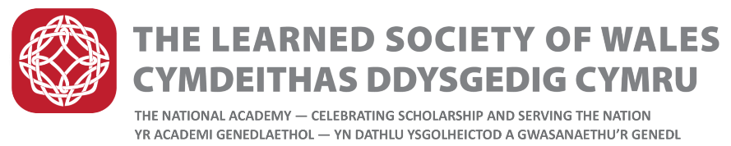
Dillwyn Medals

Revised Regulations (February 2022)

These awards are named in honour of the Dillwyn family of Swansea who achieved outstanding distinction in several fields of intellectual activity, both in the arts, social sciences and sciences.

The Dillwyn Medals will be awarded by Council of the Learned Society of Wales and will be awarded annually in recognition of excellence in early career research. Three medals will be awarded, one each in the following broad fields:
- Science, Technology, Engineering, Mathematics and Medicine;
- Social sciences, Education, and Business;
- Humanities and Creative Arts

Nominated individuals will be an early career researcher working in higher education, the public or private sector, or in industry. For the purposes of this medal award ‘Early career researcher”, covering both academic and non-academic researchers, will ordinarily be defined as a researcher within 10 years of the award of their PhD or within ten years of their first professional appointment (full-time equivalent).

- Nomination Process

- Fellows and individuals from universities, industry and the general public will be invited to submit nominations between 1st March and 30th June each year. Assessment will be carried out in July and August with winners announced in September.
- The Committee shall be free to consider persons other than those nominated.
- Nominations must come from individuals (not institutions, companies or organisations) and will need to be supported by two seconding proposers.
- Nomination forms will available from the LSW website
- Forms should be submitted electronically and in accordance with the guidance for the year.
- Sufficient information must be provided for reasoned judgements to be made
- It is the nominator’s responsibility to provide adequate information on the form
- Incomplete forms will not be considered
- A concise two page CV for the nominee must be provided with the nomination form. CVs longer than two pages will not be accepted.
- A reference is also required. This should be provided by one of the Seconders identified on the nomination form. The referee is required to be independent of the nominee’s own institution. PhD Supervisors and co-authors are not permitted to provide references. The referee must be able to provide an objective assessment of the nominee. It is the proposer’s responsibility to ask the referee to send their reference to the LSW by the closing date. Submissions without referee reports will not be considered.
- The nominee should be resident in Wales, of Welsh birth or must otherwise demonstrate a particular connection with Wales
- Unsuccessful nominations may be resubmitted in subsequent years on the appropriate forms.
- The nomination must be kept confidential between the Nominee, the Proposers and the Society

- Exclusions
The following are excluded from making nominations and being nominated:
- LSW medal Committee members
- Institutions, Organisations and Companies

- The Committee

- The Medal shall be awarded to the person deemed to be the most worthy by a Committee comprising:
- One Fellow appointed by the General Purposes Committee who shall Chair the Committee;
- Two further Fellows appointed by the General Purposes Committee ensuring a gender balance.
- Members shall serve for a term of three years, or such shorter period as the Society may decide. They will be eligible to serve for not more than two consecutive terms, following which a further period of three years shall elapse before any such member shall be eligible for re-appointment.
- The Committee may co-opt or consult further Fellows of the Society as required.
- The Committee may conduct its business through meetings or by correspondence.
- The Committee shall reach its decision on the award of the Medal at a time previous to the award ceremony to be held in September of the same year.
- The Medal shall be awarded to one person during each Year but, in the event that the Committee concludes that no person meets the appropriate standard of excellence during a particular year, a Medal shall not be awarded.
- The recipient will be awarded a specially struck commemorative medal and is expected to receive the Award in person at a ceremony. The Medal shall be normally presented by the President of the Society during a ceremony arranged by the Society in September.
- Each medal will be accompanied by a monetary prize and an LSW certificate which will also include the sponsor’s logo.
- Recipients will be invited to deliver a relevant public lecture and/or publish a short article normally within 12 months of the Award and the Society will support the medallist to do this.

