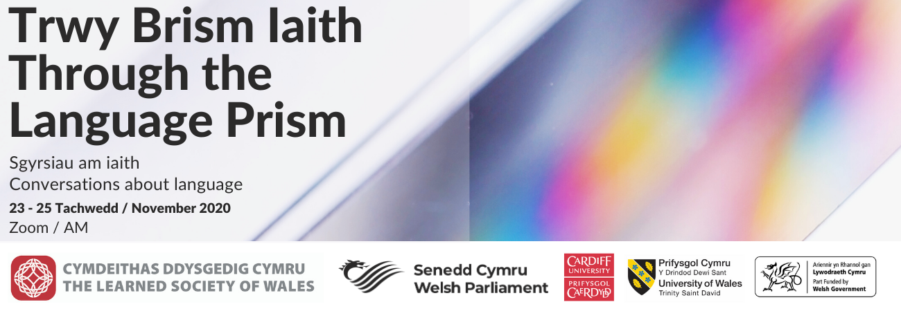

‘Mae allwedd yn yr ieithoedd hyn
I fyd sy’n sdyc dan glo.’
Gwynfor Dafydd

In November 2020, the Learned Society of Wales held a symposium on bilingualism and multilingualism. It brought together academics, practitioners and writers to discuss aspects of languages in Wales.
The symposium emerged from discussions around the need for a broader understanding of language and a holistic view of the experiences, benefits and impacts of living bi- and multilingual lives.
A steering group, led by Professor Mererid Hopwood of University of Wales Trinity Saint David (now of Aberystwyth University), developed a programme to facilitate an inclusive and wide-ranging dialogue across all aspects of language, from communication, culture and creativity, to identity, understanding and empathy.
Originally planned to be hosted at the Temple of Peace and Health in Cardiff in March 2020, the symposium was postponed due to the coronavirus outbreak. It was rescheduled for November, taking place virtually on Zoom over three days, and broadcast live on the AM platform.
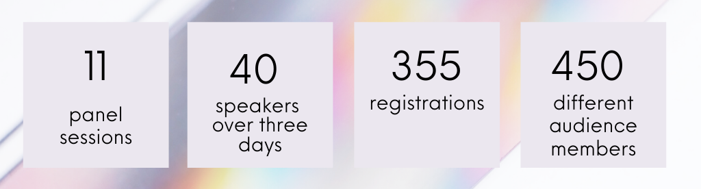
The symposium’s full programme is attached to this report. Videos of the panel discussions are available here.
Additionally, nine poets from Wales were commissioned to write poems on the subject of what language means to them. The well-received poems were shown in the breaks between sessions and are also available to view on the Society’s website.
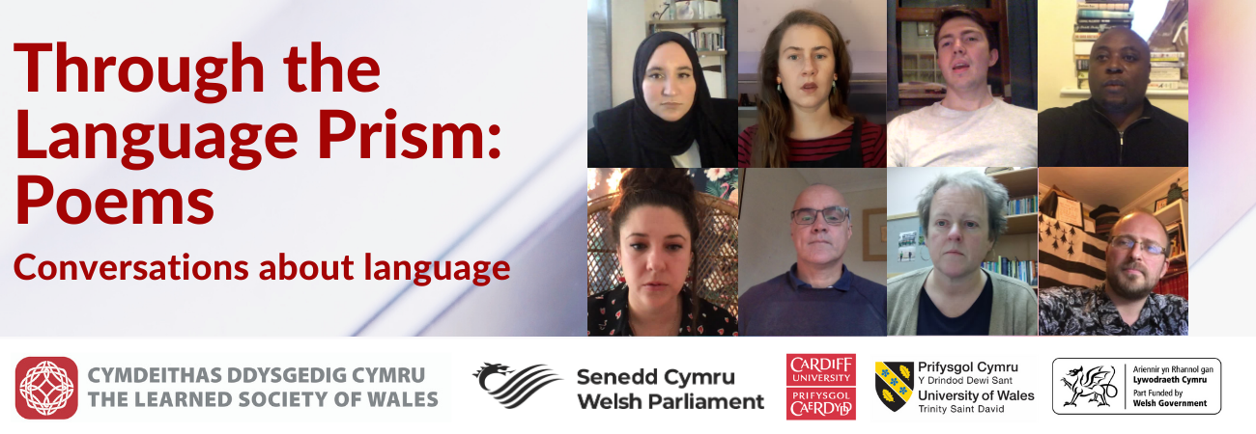

Themes and recommendations
Bilingualism and multilingualism are cross-cutting and multidisciplinary concepts that are not only the concern of linguists and educationalists. They also encompass politics, geography, psychology, literature, and sociology among others. All these were touched upon during the symposium’s sessions.
In order to distil a set of clear recommendations for society and government in Wales from these multidisciplinary discussions, the following observations have taken the new Curriculum for Wales (scheduled to be introduced in 2022) as a starting point. They focus on one of the symposium’s overriding themes, namely the need for Wales to better embrace its linguistic potential to develop a more open, inclusive and empathetic nation. Together, they are intended as pointers to how this potential might be realised.

- The new Curriculum for Wales has significant potential to develop language learning
Curriculum for Wales gives a prominent role to teaching and learning languages. Language, Literacy and Communication is one of the six areas of learning and experience within it. Learners will be expected to be confident users of Welsh, English and international languages – broadly defined in the curriculum as languages other than Welsh and English which are learned at school and which can include community languages, modern languages, classical languages and British Sign Language.
They will also be expected to be able to make connections between languages. Contributors to the symposium welcomed this as a significant opportunity to do things differently and better in the future. Furthermore, in terms of teaching and learning Welsh, the Curriculum will be a valuable instrument towards realising the Welsh Government’s goal of having a million Welsh speakers by 2050.
Contributors suggested that the following actions should be prioritised in the coming years:
- Celebrating Welsh and all other languages, thereby drawing attention to how they can enrich our lives across a wide range of experiences, by developing us as better citizens, better communicators, better employees and employers, and more creative and empathetic members of society;
- Investing in the training of teachers, tutors and other practitioners to teach languages confidently;
- Encouraging collaboration amongst language practitioners across the education sector;
- Ensuring that Welsh language learners and speakers, no matter where they position themselves on the language continuum, are encouraged and supported to become regular Welsh language users;
- Work to create a culture where learning languages is a routine practice throughout our lives.
Since 2012 there has been a significant decline in both Welsh and Welsh Second Language A-Level entries. The last decade has also seen a 53% reduction in GCSE modern language entries, and a 48% drop in A-Level entries, a rate of decline which is increasing. The Welsh Government’s Global Futures Programme (2015—22) is a positive intervention which aims to reverse this trend, and to promote the ambition for Wales to become a multilingual nation, where learners experience the range of benefits from learning international languages. This must be worked towards through the opportunities offered by the new Curriculum.
Following the UK’s departure from the EU, it is crucial that the Welsh Government explores the possibility of continued participation in the Erasmus+ programme. If association cannot be maintained, it is vital that the proposed replacement scheme, the UK Department of Education’s Turing Scheme, ensures continuity of provision and access to similar opportunities, across all nations of the UK. In the current version of proposed scheme, this is not the case.

- The experience of bilingualism and multilingualism provides many benefits
One of the recurring themes of the symposium was the notion that, as well as cognitive benefits such as greater executive control, developmental benefits, health benefits for later life and educational benefits, being bilingual and multilingual gives you ‘something else’.
This ‘something else’ was variously referred to by panel members as social qualities such as empathy, nuance, flexibility, creativity and a tolerance of ambiguity. These benefits in turn produce more rounded individuals and offer a direct route to achieving the ‘four purposes’ of the Curriculum for Wales, namely to support learners to become:
- ambitious, capable learners ready to learn throughout their lives
- enterprising, creative contributors, ready to play a full part in life and work
- ethical, informed citizens of Wales and the world
- healthy, confident individuals, ready to lead fulfilling lives as valued members of society.
This is what the image of language as a prism reveals: the clear light of language and communication is refracted into the spectrum of colour, revealing the complexity and indeed, the beauty within. The emphasis in the Curriculum for Wales on bringing languages together offers the opportunity to make learners in Wales aware of this hidden spectrum.
As Professor Guillaume Thierry of Bangor University said: “If you have different languages, you have a different approach to the same problem. You have different perspectives, different conceptions. You enrich your panoramic view of the field and domain.”
In the course of the discussions, bilingual and multilingual creative practitioners explored the multiple opportunities that their languages provide. As the author and academic Professor Angharad Price reflected in her talk at the symposium: “If we take creativity to mean the production or formation of something new or of bringing together elements in a new way, then it would seem that bilinguals or multilinguals have a ready stock of striking images, connections and wordplay at hand as possible raw material.”
The new Curriculum captures the potential of this ‘something else’ with its references to creativity, mediation, adaptability and empathy. It seeks to “empower learners to be creative and to persevere when facing challenges”. It is important that the experience of language learning and language use provides learners with the opportunity to realise the value of these essential skills and abilities and understand how they impact on the language we use in public life, and the quality of that public life.
- People use languages in different ways, and we need to recognise this
Discussions in the symposium emphasised that it does not matter which languages one learns; it is the fact of having more than one language that matters. While there may be opportunity to use some languages more often than others, there are no ‘more useful’ or ‘less useful’ languages.
The workshop on exploring multilingual selves provided an opportunity for attendees to consider their personal linguistic journeys in their lifetime, and Dr Huw Lewis’s paper outlined how he moves between Welsh and English in an average day. This act of reflection is a helpful exercise and people should be encouraged to map their language journeys to gain a better understanding of how they interact with, and make use of, their languages.
Mediation skills also have an important role in wider society. They are defined in the Curriculum for Wales guidance as “an activity in which meaning from a source is communicated from one person to another, within the same language (paraphrasing, summarising) or from one language into another (translating, interpreting). The learner assists people to communicate with one another by relaying, explaining or translating information or ideas.” The process of translating ideas from one language (and frame of reference) to another creates a space for understanding, whether the translation may take place within one mind or between two or more people.
This should be harnessed and developed into a greater recognition of the value of linguistic hospitality and empathy, which could encourage better community cohesion across Wales, and a better appreciation of other cultures internationally.
A society that seeks to be truly bilingual should also actively encourage translation as a two-way process. The sphere of public policy should work to establish a fair balance between the language of origin and the translated language.

- Policies should be better integrated
There are a number of current Welsh Government policies and ambitions relevant to language learning and language use, including:
  - the well-being goals under the Well-being of Future Generations Act;
  - the new Curriculum for Wales;
  - Cymraeg 2050: a million Welsh speakers;
  - the ‘Prosperity for All’ economic action plan;
  - the International strategy for Wales and its relevant action plans and;
  - the Nation of Sanctuary plan.

It is important that issues related to language policy and planning are cross-cutting and cohesive across a wide range of areas, leading to more impactful outcomes. For example, the outward-facing public diplomacy effort to promote greater international awareness of the Welsh language must be rooted in actions within Wales to encourage language use.

Conclusion
Co-organiser, Professor Claire Gorrara has observed that:
The paradox of multilingualism in Wales […] is that languages are everywhere and nowhere. We are surrounded by ‘creative multilingualism’ – from the sounds and signage on our streets, to the food we eat, to the online games we play and the films and TV series we watch. We need to work harder to make that multilingualism visible and to value it for the other worlds it opens for us and our children.
The symposium made evident that there is an urgent need to build awareness in Wales of the wealth of opportunities and benefits that come with bi- and multilingualism that reach far beyond the superficial ability of being able to name objects with more than one word.
The recommendations developed here offer some suggestions for the ways in which Wales can embrace and realise these opportunities and benefits and seize the advantages offered by its bilingual and multilingual experience.

February 2021

Symposium steering group members:
Professor Mererid Hopwood FLSW, University of Wales Trinity Saint David (now of Aberystwyth University)
Professor Claire Gorrara FLSW, Cardiff University
Professor Enlli Thomas, Bangor University

Supported by:
Gruffydd Jones, Senedd Commission
Dr Sarah Morse, Learned Society of Wales

https://hwb.gov.wales/curriculum-for-wales/languages-literacy-and-communication/
https://statswales.gov.wales/
https://wales.britishcouncil.org/sites/default/files/language_trends_wales_2020.pdf
https://hwb.gov.wales/curriculum-for-wales/designing-your-curriculum/developing-a-vision-for-curriculum-design/#curriculum-design-and-the-four-purposes
https://hwb.gov.wales/curriculum-for-wales/languages-literacy-and-communication/
https://hwb.gov.wales/curriculum-for-wales/languages-literacy-and-communication/statements-of-what-matters
https://wales.britishcouncil.org/en/blog/languages-multilingualism

