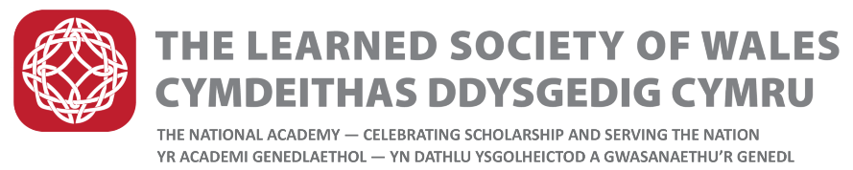
Dillwyn Medals Regulations

These awards are named in honour of the Dillwyn family of Swansea who achieved outstanding distinction in several fields of intellectual activity, both in the arts, social sciences and sciences.

- The Dillwyn Medals will be awarded by Council of the Learned Society of Wales and will be awarded annually in recognition of excellence in early career research. Three medals will be awarded, one each in the following broad fields:
- Science, Technology, Engineering, Mathematics and Medicine;
- Social sciences, Education, and Business;
- Humanities and Creative Arts

- Nominated individuals will be an early career researcher working in higher education, the public or private sector, or in industry. For the purposes of this medal award ‘Early career researcher”, covering both academic and non-academic researchers, will ordinarily be defined as “a researcher with a minimum of two years’ work experience and no more than ten years work experience". Eligible candidates should be "individuals who have demonstrated outstanding ability in their work, research and professional practice” and at least 6 years past graduation of first degree.

- Nomination Process
- Fellows and individuals from universities, industry and the general public are invited to submit nominations
- Nominations must come from individuals (not institutions, companies or organisations)
- Nomination forms are available from the LSW website
- Electronic forms should be properly submitted and duly authorised
- It is important that sufficient relevant information is provided for reasoned judgements to be made
- It is the nominator’s responsibility to provide adequate information on the form
- Incomplete forms will not be considered
- A concise two page CV for the nominee must be provided with the nomination form. CVs longer than two pages will not be accepted.
- A reference is also required. This should be provided by one of the Seconders identified on the nomination form. The referee is required to be independent of the nominee’s own institution. PhD Supervisors and co-authors are not permitted to provide references. The referee must be able to provide an objective assessment of the candidate. It is the proposer’s responsibility to ask the referee to send their reference to the LSW by the closing date. Submissions without referee reports will not be considered
- The nominee should be resident in Wales, of Welsh birth or must otherwise demonstrate a particular connection with Wales
- The nomination is submitted in confidence without the knowledge of the nominee
- Nominations will only be considered for one medal cycle, and unsuccessful nominations will not be rolled over
- The nomination must be kept confidential between the Candidate, the Proposers and the Society
- Exclusion from making nominations
The following are excluded from making nominations:
- Dillwyn Medal Committee members
- Institutions, Organisations and Companies

- The Committees
- The 3 Medals shall be awarded to persons deemed most worthy by the Committees (one for each of the broad subject areas)
- Committee members will be appointed by Council and each committee shall comprise:
A Chair and two further Fellows from among the Fellows of the Society
- The Committee may co-opt and /or consult further Fellows of the Society as required
- Appointed and co-opted members shall serve for a term of three years, or such shorter period as the appointing body may decide. They will be eligible to serve for not more than two consecutive terms, following which a further period of three years shall elapse before any such member shall be eligible for re-appointment
- The Committee may conduct its business through meetings or by correspondence.
- Conditions of Award
- Each of the Dillwyn Medals will be awarded to one person during each Society Year (being the period between Annual General Meetings of the Society) but, in the event that the Committee concludes that no person meets the appropriate standard of excellence during a particular Society Year, a Medal shall not be awarded.
- The recipients will be awarded a specially struck commemorative medal and are expected to receive the Award in person at a ceremony. The Medal shall be normally presented by the President of the Society during a ceremony on the same day as the Society’s AGM (in mid-May), arranged by the Society
- Each medal will be accompanied by a monetary prize and a certificate
- Award recipients are required, to deliver a relevant public lecture and / or publish a short article that could be used to raise the profile of early career research in Wales. Such a lecture should be suitable for a non-specialist audience. The Society will bear the costs associated with this lecture such as advertising, provision of rooms and audiovisual aids

Last updated: 1 December 2020

