Wales and the World:

Global partnerships, local benefits

Introduction
Between October 2019 and October 2020, the Learned Society of Wales organised a series of four Wales and the World events. Our aim was to expand discussions around Wales’s international assets, and to help answer a key question: How should Wales project itself on the world stage?
We conceived the series to coincide with the Welsh Government’s development of a new International Strategy, launched at the start of 2020. That strategy built on the commitment to sustainable development enshrined in the Well-being of Future Generations Act and on the need to respond to the UK’s withdrawal from the European Union. It has been followed by a set of Welsh Government action plans.
We wanted to encourage constructive critical analysis of Wales’s position in the world, discuss how we can exercise soft power, and expand on opportunities for international engagement in areas such as the arts, culture, the Welsh language, sport, higher education and research.
As the International Strategy noted, “The world changes constantly and Wales changes with it.” Soon after our third event, the great global challenge posed by the coronavirus pandemic became clear. With it came a reassessment of how we live, work and communicate. Despite restrictions on travel and migration, the pandemic provided a clear insight into shared global challenges – especially in the health sphere – and the interdependence that goes beyond international borders.
Our final event took place online, some months after the originally envisaged date. That delay gave us time to reflect on the previous discussions and to reframe our challenges in the new context. While the effects of the pandemic have been devastating, there is heightened awareness of the role of devolved governments. As our keynote speaker Laura McAllister argued, this could increase the scope for Wales to follow a distinctive international path, even within the constraints on our lives, political competence and the economy.
Devolution and relations within the United Kingdom were recurring themes. In addressing the international dimension, we have not focused significantly on these issues. But we recognise the importance of these relations for Wales, including its global projection. By definition, the role of the Welsh Government is pivotal and embraces leadership, financing and the levers of government. But the vision which emerged is much broader, with a role for individuals and many organisations. Government therefore has a wide enabling role which encourages that involvement and participation to deliver widespread benefit.
This report summarises the key areas of discussion covered by the four events and makes several recommendations. It is not a detailed policy statement, but a set of proposals for taking the next steps – for highlighting Wales’s unique assets and developing our collective potential in the face of global challenges.

Overarching recommendations
In addition to specific recommendations under each of our themes, we have drawn out four messages relevant to all of them. They provide a useful summary of how Wales can build on the current efforts of government, public bodies, universities, communities and industry.
- Wales should define its distinctive qualities more clearly, and should be self-confident in promoting these internationally. Our bilingual nation has a distinctive heritage, and a strong sense of values, community and internationalism. We need to draw out these qualities through engagement with a wide range of voices, and to recruit diverse ambassadors for Wales on the world stage, including investors in Wales.
- Using our ‘soft power’ wisely leads to ‘hard benefits’. Wales’s qualities and values are attractive to its international partners; they help Wales to develop its profile beyond the UK dimension. There are cultural and ethical benefits to doing so – and, in the longer term, economic benefits for Wales.
- Longer-term planning and financial investment are needed. Building national self-confidence and a distinctive international presence is the work of decades, not years. International strategies should therefore take the long view and should be co-created with stakeholders outside government. The actions that derive from these strategies will require significant, strategic investment from government, and this will pay off in the longer term.
- Wales should make better use of UK and international institutions and expect more of them. While Wales has a distinctive voice, the UK dimension is vital to our success. Welsh Government, universities and other institutions need to develop closer relations with UK bodies – taking every opportunity to improve their representation of Wales. Wales may also play an increased role in international institutions such as UNESCO, promoting Wales’ values and its interests.

Sponsors
We are grateful to the Welsh Government and Higher Education Funding Council for Wales for their financial sponsorship of this project. We also thank Cardiff Metropolitan University, National Museum Wales, Bangor University and Aberystwyth University for hosting the events.

Theme 1: Wales’s International Relations and ‘Soft Power’
Under this theme, we considered the overall assets that Wales can use to strengthen its international perception, and how these assets might best be used.
We drew on the idea of soft power: the ‘power of attraction’ that a country can hold for people and governments in other countries, and for international organisations. This is a useful way to think about how Wales – as a small nation without hard sovereign power – can exercise its influence. We discussed Wales’s soft power assets, including:
- Heritage and culture – including poetry, literature, song, dance and food
- The Welsh language and bilingualism
- Values, ideas and global responsibility – captured through Wales’s work on sustainability and international development
- Research and innovation by our universities and their partners
- Sports and sportspeople
The concept of soft power was used as a springboard for discussion, but not all our participants supported this label. The Welsh Government uses the phrase ‘public diplomacy’ instead. Some felt that the idea of ‘smart power’ was more helpful – combining our ‘soft’ assets with a ‘harder’ edge that demands real investment, and a real return for Wales and its people. We must be patient, as these hard benefits may take some time to realise. Longer-term strategies are therefore required.
It was acknowledged that the Welsh Government’s primary objective is to look after the interests of Welsh people, and this must be the goal of our international actions. However, this emphatically does not mean we should act in an insular way. We must balance Wales’s needs while responding to international challenges – acting in a globally responsible manner that is consistent with ministerial speeches and government commitments.
Many participants welcomed the Welsh Government’s appointment of a minister with explicit responsibility for International Relations. This was a strong opportunity to make the international dimension a top priority for government. Some expressed disappointment that, by the time of the last event in the series, these responsibilities remained primarily the focus of other ministers’ portfolios.

Harnessing our assets
Participants agreed that the challenge is to harness our soft power assets and channel them into meaningful international influence. Over-generalised claims, clichés and nostalgia should be avoided. The focus should be on articulating wider national ambitions, and on the genuinely special characteristics that mark out Wales (such as the Welsh language). Our actions must go beyond a ‘marketing’ exercise – we must exude a genuine confidence in the national credibility of Wales.
To some extent, this can be achieved by the Welsh Government and public sector agencies in collaboration with our national institutions. Previously, the Welsh Development Agency was positively engaged in Wales’s international promotion. While views differ on the effectiveness of the WDA’s approach, a renewed consideration of international, semi-autonomous agencies would be helpful. The private sector has a key role in promoting Wales.
However, soft power also rests on networks of influence, and an informality that does not always sit easily with governmental or quasi-governmental approaches. Any overarching strategy should itself be developed in alliance with other stakeholders. The Welsh Government itself recognises that “Many of [the] levels of influence sit outside of government… government cannot work alone, nor should it.”
Many participants felt we should go further than collaboration, and that people, communities and civil society should play leading roles in developing Wales’s international strategy. A diverse range of voices from Wales should be included, both in strategic development and practically as our international ‘ambassadors’. Such ambassadors should include Welsh language learners and Welsh diaspora overseas. Welsh Government’s action plan for diaspora engagement includes several useful recruitment initiatives, but makes little mention of a diversity requirement.
Our efforts to project Wales must crucially also reflect the values we are trying to project. In this respect, the Welsh Government’s commitment to champion diversity, fairness and equality in its international work is welcome.
Sport offers one, hitherto under-utilised, way to convey the identity and values of Wales. While sport was not a focus theme of our events, participants agreed that the profile and diversity of Welsh sportspeople could make a strong impact on our international projection. Sport places emphasis on success, and this mindset could be translated to other contexts, such as Welsh action on sustainable development. The British Council published a detailed report on Welsh sports diplomacy in 2020, so our report does not make specific recommendations in this area.
Finally, while school-level education was outside the remit of these events, we also noted that the new national curriculum provides important opportunities to consider Welsh and international dimensions in tandem. Young people have an important role to play in projecting Wales internationally.

The UK dimension
Wales does not, of course, have competence over most of the ‘hard power’ aspects of international relations. These are controlled by the UK Government, and this distinctive constitutional feature holds both opportunities and constraints.
UK bodies such as the British Council and BBC can be an important magnifier of Welsh assets, and their potential should be maximised. There is also the potential to reach out through the UK’s overseas embassies to Welsh diaspora, using the UK ‘brand’ to Wales’s advantage where possible.
However, the UK context brings its challenges. The reality is that Wales remains underrepresented in many of the UK’s overseas missions and within the thinking of the Foreign and Commonwealth Office. Wales should strive to strengthen its position within UK structures and challenge them to do more for Wales, as there is a tendency for our identity to be lost within large-scale campaigns such as Global Britain. Where such campaigns do exist, Wales needs to push to ensure it is represented.
We must press Wales’s position within UK structures, while at the same time making concerted efforts to strengthen our own, Welsh national institutions.

The European dimension
With the UK’s departure from the European Union, the future of UK-EU relations remains unclear. Wales needs to keep open the possibility of cooperation with EU agencies and programmes. It is also important for Wales to maintain the relationships it has established with other European partners, collaborators and inter-governmental networks, both national and pan-Europe. Maintaining such links will also help Wales draw on the practice of other small European nations that have strong models of international outreach, such as Ireland and the Baltic states.

Recommendations
  - International strategies and plans should identify, clearly and confidently, the distinctive characteristics that mark out Wales. In addition to the Welsh language, such characteristics may include Wales’s inclusivity, social progressiveness, and commitment to sustainable development. Care should be taken to ensure that the characteristics go beyond generic values that many other countries could claim to embody. The Welsh Government should engage more fully with communities in Wales and with Welsh diaspora overseas to identify those distinctive characteristics, and to define them in terms that are specific, non-stereotypical, and illustrated with examples of people associated with Wales.
  - A diverse range of national ‘ambassadors’ should be identified and supported to promote Wales internationally. These should include artists and performers, sportspeople, community activists, Welsh language learners, and Welsh diaspora overseas. Ambassadors should represent the diverse stories and histories of Wales, and should project a country with both a strong heritage and a forward-looking, positive view of the world. Government should be supportive of our ambassadors, giving them space to create networks of influence without being constrained by bureaucracy.
  - Welsh institutions should increase capacity for international projection by improving their use of UK infrastructure. This infrastructure includes public bodies, embassies and consulates that operate overseas, as well as international campaigns conducted by the UK Government. Welsh Government and other institutions should take every opportunity to channel Welsh identity and ambitions through these channels, and to establish improved communication and collaboration at UK level. This may require a more self-confident, sometimes insistent, approach to Wales-UK relations.
  - The Welsh Government should provide more funding and support for the international role of national institutions. These institutions – including the National Library of Wales, National Museum Wales, Books Council of Wales, Arts Council Wales, Sport Wales, our universities, the University of Wales Press and the Learned Society of Wales itself – not only play a vital role in our cultural promotion, but also in the Wales’s ‘hard’ diplomatic self-assertion. They need to exude confidence and independence when asserting themselves internationally.

Theme 2: Universities as Global Communities
Within this second theme, we looked at the contributions made by higher education and research to Wales’s international profile.
Our universities are inherently international spaces. They recruit students and staff from many countries and cultural backgrounds; they encourage study within global contexts; they engage in educational and research partnerships with numerous institutions overseas. Increasingly, universities also strive to bring the benefits of these global connections to the local communities in which they are based.

The position of Welsh universities
Eight universities are based in Wales, with specialisms covering a wide range of academic disciplines. The evidence shows that research in Wales is of high quality – globally cited, impactful, internationally engaged, and excellent value for money. However, our capacity for research and development is small. Research and development (R&D) expenditure in Wales currently represents around 2% of the UK’s total R&D expenditure, and has relied quite significantly upon European Union Structural Funds. Their proposed replacement, the Shared Prosperity Fund, risks being more centrally managed by the UK Government; its distribution should be related to nations’ and regions’ needs. Further Welsh and UK government funding to provide a level playing field is critical to maintain the international mission of the sector.
Higher education is mostly a devolved competency for the Welsh Government, but is part of a UK system in terms of quality assessment, research funding, immigration policy and other areas. It is important that Wales is represented successfully at the UK level, while carving out a distinctive presence that enables our universities to compete and succeed on their own merits. Global Wales is well placed to develop this work further through its international promotional work and mobility funds.
Participants also noted that currently, our institutions do not draw sufficiently on UK institutions we can access – such as the British Council, the BBC and international campaigns. Some difficult negotiations may be needed for Wales to balance this dimension with its wish to project a distinctive profile (see below), but the UK higher education ‘brand’ is very strong.

A distinctive international profile
Universities across the UK are active in many countries, and the UK higher education sector as a whole has a strong international reputation. In the main, Wales’s institutions are relatively low-profile within international league tables and other measures such as research grant capture.
A challenge for the sector in Wales is, therefore, to develop a distinctive profile within the UK brand that emphasises Welsh ambitions and values. There is scope to do this through the national policy context: particularly its emphasis on sustainable development and a low-carbon future. But it is not enough to promote our universities’ world-leading work in this area, or to trumpet the Well-being of Future Generations Act as a piece of legislation. We also need stronger collaboration to develop new technologies, infrastructure and behaviour; and our teaching needs to reflect this approach. Action and implementation need to follow excellent concepts.
If we seize these opportunities, Wales can help to shape global discourses. Such activities can be a counterpart to the Welsh Government’s strengthened commitment to work with the Future Generations Commissioner and other partners on international sustainability initiatives.
Wales’s ability to translate international goals into action is one distinctive characteristic that we can use to develop our universities’ international profile. Others include:
- A strong sense of community – a place in which people can thrive in safety
- Our status as a small nation – giving students, staff and alumni a sense of connectedness to Wales
- The Welsh language, Celtic connections, and expertise in bilingual and multilingual working
- Diverse, culturally integrated university campuses
- The small size of the sector, which lends itself to collaboration between Welsh institutions to forge international partnerships
This last point requires the development of a shared vision and a more effective joint working space for Welsh universities. A more formal collaborative structure, as recommended by Professor Graeme Reid in his recent Strength in Diversity report, would be helpful.
Our sector will not always need to rely on the distinctiveness of Wales for its success. Ultimately, a flexible approach is needed, with partnerships and individual institutions making strategic choices to deploy the country’s unique characteristics as appropriate.

Effective international partnership
Wales’s researchers already collaborate successfully with institutions in many countries and across many academic disciplines. There are existing initiatives to support recruitment of the best researchers to Wales, and to translate this to economic development outcomes (e.g. the Welsh Government’s Sêr Cymru programme). While Brexit is presenting practical and financial challenges to European collaborations, international partners still have a strong appetite to collaborate with UK – including Welsh – institutions.
There is scope to develop partnerships further, and a need for long-term, sustainable and values-based partnerships that establish Welsh institutions as ‘partners of choice’. Again, a focus on our distinctive assets – such as our bilingualism and ‘small nation’ approach – would serve Wales well. Working more closely with other institutions such as Welsh and UK Government offices overseas, and with the British Council, would help improve access to wider international networks.
Our universities also need to collaborate more strongly with Wales-based cultural institutions that share their global ambitions, such as museums and sporting bodies.
In all these cases, improved collaboration between universities may help to secure such partnerships.

Engaging people and communities
To develop as global communities, our universities cannot only engage with other institutions. They should also consider the voices and views of domestic and international students, staff, and their own alumni living and working in other countries. All these groups can play a vital role in projecting a positive image of Wales and its institutions. The benefits brought by international students to communities in Wales should not be forgotten.
Our participants stressed that it is not enough to do positive things internationally; it is also important to share the benefits of this work with Wales and its communities. Universities must work hard to consider how their work translates into practical outcomes for the people of Wales. We must remember that taxpayers are financial stakeholders in higher education, and – especially in the Covid-19 context – expenditure on universities will come under increasing pressure. Increasingly, universities across Europe are shaping their research targets in consultation with local communities; this is an area for Wales to develop.
Using international connections to benefit our communities is an important part of universities’ civic mission. It requires sufficient funding and further consideration of how civic mission can be delivered through cross-Wales collaboration.

Recommendations
- The eight universities of Wales should increase their cooperation on international work. They can promote Welsh interests, and the diversity of our university sector, jointly alongside the interests of their individual institutions. Specific consideration should be given to greater alignment of research funding proposals and jointly developed international partnerships.
- Universities should be more assertive in drawing on the capacities of UK-wide institutions, including the Foreign and Commonwealth Office, the BBC, the Department for International Development, and the British Council’s global network of offices. The sector should also urge those bodies to better reflect the distinct attributes of Wales in their work.
- International students should be key partners in the projection of Wales. Universities should seek to involve them more actively in all aspects of campus life, should take their experiences into account more regularly, and should consider their views when planning marketing activities in different countries. They should be engaged more consistently in civic mission activities in Wales.
- Universities should build on the work of Global Wales to improve how they harness the ‘soft power’ of their alumni overseas. The potential for a collaborative all-Wales alumni association should be explored, as well as opportunities to enrich the sector by bringing talented alumni back to Wales for short periods.
- Universities should review how their international activities support communities in Wales. Communities should see tangible benefits that go beyond ‘marketing’ exercises, and should be consulted and engaged in co-producing activities wherever possible.

Theme 3: The Role of Arts, Culture and the Welsh Language
Within this theme, we considered several vital facets of Welsh identity which may be considered ‘soft power assets’.
The Welsh language is, of course, a unique asset which gives us a particular voice in the world. Having two official languages also places Wales alongside the many other nations and regions for whom bilingualism, or multilingualism, is the norm. It helps us to connect, especially with other small nations. Wales’s approach to protecting and promoting Welsh is of international importance, and it is a leading exponent of new language technologies.
The two languages, and the literature and other art forms which use them, form part of a distinctive culture that we can celebrate both within Wales and globally. These are supported by internationally renowned events, such as the Urdd and National Eisteddfodau and Hay Festival, and key institutions such as the National Museum, Theatre, Dance and Opera. Our other assets, such as TV production, may not always be distinctively Welsh but are of international quality. Small companies, social media and the digital economy have strong contributions to make.
There are opportunities to build on our cultural assets both independently and within the UK context. However, there is much work to be done to ensure those narratives are genuinely inclusive of Wales. Without a proper recovery plan, Covid-19 also poses a challenge to the very existence of parts of the arts and culture sector.

National identity
We explored the connection between arts, culture and language and Wales’s overall national characteristics. Some participants had experienced warm responses, internationally, to Wales and Welsh identity. However, others pointed to a significant lack of international awareness, or understanding, of Wales. If culture, arts and language are integral to that identity, it will be essential to invest more in their development and promotion.
Linking arts and culture with other key aspects of our national identity – especially the approach to sustainable development highlighted in the Well-being of Future Generations Act – will help them to resonate internationally. Such topics are not purely about legislation or planning; they symbolise a progressive Welsh identity that is also reflected in our cultural products.
Participants stressed that Wales’s history and culture should not be presented in ways that are clichéd or anachronistic. Wales encompasses a rich multitude of voices, identities and histories which should be reflected in what we project internationally. We must not become a kind of cultural ‘theme park’.

Co-production and collaboration
Our national institutions and creative industries play a vital role in promoting Welsh culture and values. However, ultimately it is people who create and share culture. It is important that people and communities throughout Wales have ample opportunity to explore their histories and identities, and that their voices are respected in Wales’s international projection. This will help to ensure that projection is authentic, self-confident and successful. Knowing more of ourselves and at the same time being outward looking is a double bonus. To engage with people in this way, our institutions need greater financial investment.
Some participants felt that Wales already has a democratic approach to its culture, and is developing a strong reputation for cultural co-production and collaboration. For example, the redevelopment of St Fagans in Cardiff as the National Museum of History, with an emphasis on community engagement, has attracted international attention. We need to build on these examples, and to take time to talk to our international partners as we pursue long-term cultural partnerships. Our plans for international engagement should be sensitive to the needs, and interests, of different cultures. It is important not to create activities that inadvertently ‘impose’ one Welsh culture on others.
We must also avoid seeing arts and culture as being divorced from other ‘selling points’ of Wales. For example, the creative arts are a technologically sophisticated industry, so linking their promotion to that of technology is a natural fit. We need to create more opportunities for organisations involved in international promotion to come together, share their activities, and learn from each other.

International engagement
Wales must more clearly define its aims in international cultural engagement. While certain aspects of ‘selling Wales’ are clearly outlined in the Welsh Government’s International Strategy – such as our specialisms in industry – the cultural and linguistic aspects are less well defined. It is positive that since the publication of the strategy, Government has produced a supplementary action plan that encompasses cultural diplomacy, proposing a range of actions to 2025.
Overall, Wales needs to be more ambitious in its international engagement. We can go beyond existing activities and develop concepts for new, major international cultural programmes, highlighting Wales’s heritage within a modern and diverse context. Such programmes will be able to take full advantage of our bilingualism and ability to champion indigenous languages.
At present, it is difficult for Wales’s approach to be reflected within UK narratives. Representations of Welsh culture in UK campaigns are sparse, which is symptomatic of a lack of consultation by the UK Government of Welsh institutions. Our cultural organisations therefore experience a power imbalance within the UK relationship. British Council Wales can play a helpful intermediary role in this regard.
Wales also has opportunities to engage directly with international organisations and initiatives. We have not always capitalised on these opportunities. For example, there was relatively little engagement with the 2019 UNESCO International Year of Indigenous Languages, which could have been a key opportunity to promote the Welsh language. It is positive that Welsh Government recognises, in its action plan, several opportunities to improve this situation.

Recommendations
- Wales needs a long-term, modern strategy for the international promotion of its culture, arts and language. This should be co-created with communities across Wales, should encompass diverse voices and perspectives, and should project a self-confident Wales at ease with both its heritage and modern identities.
- The Welsh Government should protect and enhance investment in Wales’s national cultural institutions, to ensure they are equipped to play their part internationally. While such investment may be challenging in a post-pandemic context, it is vital that our institutions do not lose their ability to engage people both locally and internationally. With enough investment, this approach will create both cultural benefits and, ultimately, ‘hard’ economic benefits for Wales.
- Wales should take every opportunity to benefit from UK and international initiatives that enhance our cultural presence. Government, cultural institutions and creative industries all have a part to play in maximising Wales’s engagement with initiatives that already exist, and in planning sufficiently far ahead to ensure successful engagement.

Appendix: events and Key Contributors

Events in the series
- Soft Power Strategies – How Should Wales Project Itself on the World Stage?
28 October 2019
Hosted by Cardiff Metropolitan University

- The Role of Arts and Culture in Developing Wales’s International Profile
10 December 2019
Hosted by National Museum Cardiff

- Universities as Global Communities
13 February 2020
Hosted by Bangor University

- Promoting Wales Internationally: The Next Steps
22 October 2020
Hosted by Aberystwyth University
Individual reports on the first three events are available on the Learned Society of Wales website. This report reflects on the topics covered by those events, and the next steps discussed at the final event, which drew together all the themes.

Key contributors
We are grateful to everyone who contributed so thoughtfully to this series of events, especially:

Professor Cara Aitchison | Vice-Chancellor, Cardiff Metropolitan University
David Anderson | Director General, National Museum Wales
Paul Brummell | Head of Soft Power and External Affairs Department, Foreign and Commonwealth Office, UK Government
Dr Gavin Bunting | Associate Professor – College of Engineering, Swansea University
Mark Cadwallader | Director of Strategy and Development, University of South Wales
Professor Iwan Davies | Vice-Chancellor, Bangor University
Peter Florence | Hay Festival
Rebecca Gould | British Council Wales
Llinos Griffin Williams | Wildflame Media
Eluned Haf | Head of Wales Arts International
Professor Simon Haslett | Pro Vice-Chancellor (International and Engagement), University of Wales Trinity Saint David
Owen Hathaway | Sport Wales
Professor Mererid Hopwood | University of Wales Trinity Saint David
Rob Humphreys | HEFCW Council member & Trustee, British Council
Dr Anwen Jones | Pro Vice-Chancellor – Faculty of Arts and Social Sciences, Aberystwyth University
Sir Emyr Jones Parry | President (2014-2020), Learned Society of Wales
Helgard Krause | Chief Executive, Books Council Wales
Professor Milja Kurki | Department of International Politics, Aberystwyth University
Imants Liegis | Latvian Ambassador to France
Professor Colin McInnes | Pro Vice-Chancellor – Research, Knowledge Exchange and Innovation, Aberystwyth University
Dr Maggie Parke | Bangor University / Universities Wales
Eluned Morgan AM | Minister for International Relations and Welsh Language (2018-20), Welsh Government
Professor Karen Smith | Head of Department of International Relations, LSE
Professor Phil Stephens | Dean of International & Engagement, College of Biomedical and Life Sciences, Cardiff University
Vivienne Stern | Director, Universities UK International
Professor Elizabeth T. Treasure | Vice-Chancellor, Aberystwyth University
Susie Ventris-Field | Chief Executive, Welsh Centre for International Affairs
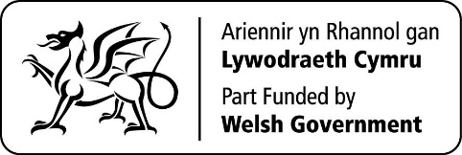
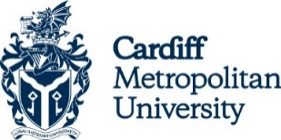 | 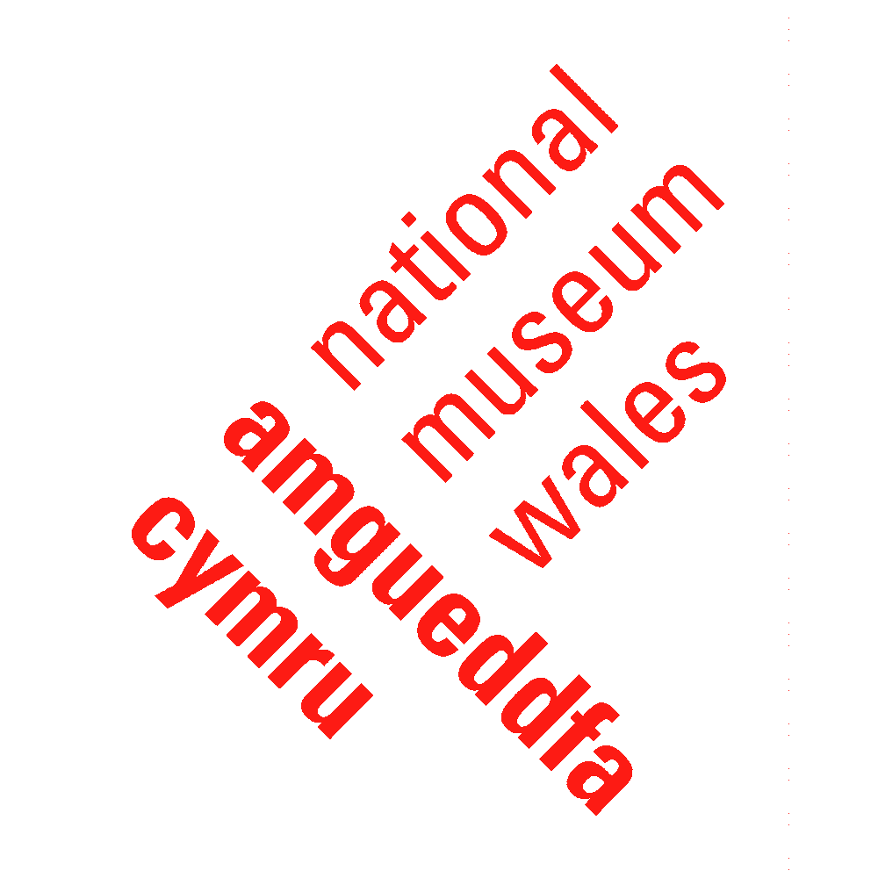 | 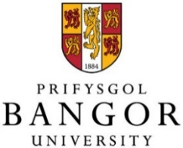

‘International Strategy for Wales’, Welsh Government, January 2020, https://gov.wales/international-strategy-for-wales
See ‘Well-being of Future Generations (Wales) Act 2015’, Future Generations Commissioner for Wales, https://www.futuregenerations.wales/about-us/future-generations-act/
‘International action plans’, Welsh Government, 2020, https://gov.wales/international-action-plans
‘Action Plan: International Relations through Public Diplomacy and Soft Power 2020-2025’, Welsh Government, 2020, https://gov.wales/sites/default/files/publications/2020-11/international-relations-through-public-diplomacy-soft-power.pdf
‘Action Plan: International Relations through Public Diplomacy and Soft Power 2020-2025’ (see note 4)
‘Action Plan: Diaspora Engagement 2020-2025’, Welsh Government, 2020, https://gov.wales/sites/default/files/publications/2020-11/diaspora-action-plan.pdf
‘Towards a Welsh sports diplomacy strategy’, Murray, Stuart and Price, Gavin, British Council Wales, October 2020, https://wales.britishcouncil.org/sites/default/files/towards_a_welsh_sports_diplomacy_strategy_0.pdf
‘Global Britain: delivering on our international ambition’, UK Government, June 2018, updated September 2019, https://www.gov.uk/government/collections/global-britain-delivering-on-our-international-ambition
‘Wales and the World’, Learned Society of Wales, October 2017, https://www.learnedsociety.wales/our-publications/wales-and-the-world/
2.1% in 2018 – see ‘Research and development gross expenditure: 2018’, Welsh Government, July 2020, https://gov.wales/research-and-development-business-enterprise-expenditure-2019
‘The European Structural and Investment Funds – Contribution to UK research and innovation’, British Academy / Learned Society of Wales / Royal Society of Edinburgh / Royal Irish Academy, April 2020, https://www.learnedsociety.wales/wp-content/uploads/2020/04/2020-04-20-Structural-Funds-Explainer.pdf
‘Global Wales’, Universities Wales, March 2019, https://www.uniswales.ac.uk/global-wales/
‘Action Plan: International Relations through Public Diplomacy and Soft Power 2020-2025’ (see note 4)
‘Strength in Diversity: Exploring opportunities for collaboration in research and innovation between universities in Wales’, Reid, Graeme, September 2020, https://uniswales.ac.uk/media/Strength-in-Diversity-Professor-Graeme-Reid-FINAL.pdf
‘Sêr Cymru’, Welsh Government, June 2019, https://gov.wales/ser-cymru
‘A new kind of museum for Wales’, National Museum Wales, October 2018, https://museum.wales/news/?article_id=1121
‘Action Plan: International Relations through Public Diplomacy and Soft Power 2020-2025’ (see note 4)
‘Wales and the World – past events’, Learned Society of Wales, https://www.learnedsociety.wales/wales-and-the-world-past-events/

