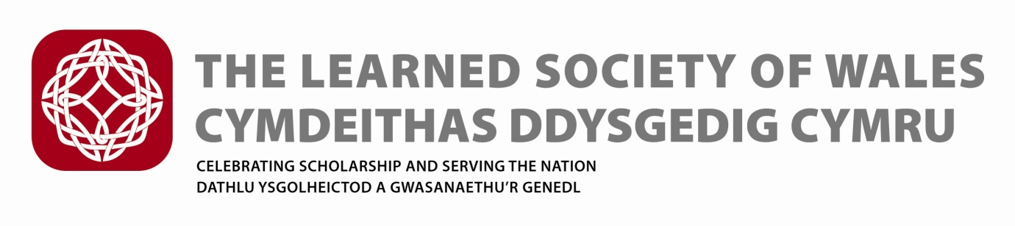
The Frances Hoggan Medal Regulations (Agreed by Council 16 October 2019)
The Award (medal and prize money) is sponsored by the Welsh Government.
Sponsor support for the medal is for an initial 5 year period with an option for review at Year 3.

The award is named in honour of Dr Frances Hoggan (née Morgan) (1843 –1927), from Brecon, the first British woman to receive a medical doctorate from a university in Europe. The first award will be made in 2015/16.

The award is made to support the promotion and recognition of women engaged in research in science, medicine, engineering or mathematics. The Secretariat secured agreement from members of Hoggan’s family.

- The Frances Hoggan Medal of the Learned Society of Wales will be awarded annually in recognition of an outstanding contribution to research in any area of Science, Technology, Engineering, Mathematics and Medicine (STEMM) research, by a woman, resident in Wales, of Welsh birth or who otherwise can demonstrate a particular connection with Wales

- The recipient should be a woman actively engaged in research in the public or private sector or in industry. The research should be based in a scientific, technological, engineering, mathematics or medical discipline, including the scientific aspects of subjects such as geography and archaeology. There are no restrictions on the age of the nominees, and nominees who have taken a career break will also be considered.

- Nomination Process

  - Fellows and individuals from universities, industry and the general public will be invited to submit nominations no less than 12 weeks before the Annual General Meeting which marks the end of the Society Year during which the Medal shall be awarded.
  - The Committee shall be free to consider persons other than those nominated.
  - Nominations which have to come from individuals (not institutions, companies or organisations) will need be supported by two seconding proposers
  - Nomination forms will available from the LSW website
  - Electronic forms should be submitted with electronic signatures where possible
  - If electronic signatures are not available then a signed hard copy must be submitted
  - Sufficient information must be provided for reasoned judgements to be made
  - It is the nominator’s responsibility to provide adequate information on the form
  - Incomplete forms will not be considered
  - Unsuccessful nominations will be retained for further consideration by the Committee for a period of 3 years (including the year in which they are submitted), following which they shall cease to be valid for consideration.
  - The nomination must be kept confidential between the Candidate, the Proposers and the Society

- Exclusion from making nominations

The following are excluded from making nominations:

- LSW Prize Committee members
- Institutions , Organisations and Companies

The following are excluded from being nominated:

- LSW Council members
- LSW Prize Committee members
- Institutions , Organisations and Companies

- The Committee

- The Medal shall be awarded to the person deemed to be the most worthy by a Committee comprising:
- One person appointed by Council who shall Chair the Committee;
- Four further Fellows appointed by the Council of the Learned Society of Wales from among the Fellows of the Society (Science, Technology and Medicine);
- At least three members of the Committee shall be female, and no more than two members shall be LSW Council Members.
- Appointed and co-opted members shall serve for a term of three years, or such shorter period as the appointing body may decide. They will be eligible to serve for not more than two consecutive terms, following which a further period of three years shall elapse before any such member shall be eligible for re-appointment.
- The Committee may co-opt or consult further Fellows of the Society as required.
- The Committee may conduct its business through meetings; the quorum of the Committee shall be three.
- The Committee shall reach its decision on the award of the Medal no less than eight weeks before the Annual General Meeting which marks the end of the Society Year in question.

- The Medal shall be awarded to one person during each Society Year (being the period between Annual General Meetings of the Society) but, in the event that the Committee concludes that no person meets the appropriate standard of excellence during a particular Society Year, a Medal shall not be awarded.

- The recipient will be awarded a specially struck commemorative medal and is expected to receive the Award in person at a ceremony. The Medal shall be normally presented by the President of the Society during a ceremony on the same day as the Society’s AGM (in mid-May), arranged by the Society.

- Each medal will be accompanied by a monetary prize and a LSW certificate which will also include the sponsor’s logo.

- Recipients are required to provide a relevant public lecture and/ or publish a short article that could be used to raise the profile of women in STEMM in Wales and the UK within 6 months of the Award. Such a lecture should be suitable for a non-specialist audience, including school children in the 16-19 year age group. The Society will bear the costs associated with this lecture such as advertising, provision of rooms and audiovisual aids.

