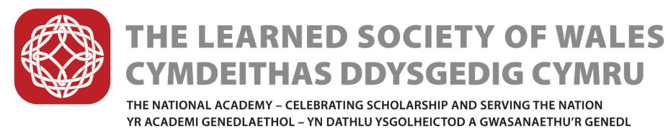
Annual General Meeting, 23 May 2018  Cyfarfod Cyffredinol Blynyddol, 23 Mai 2018 | AGM/2018/05  Agendum 8  CCB/2018/05  Agendwm 8

Wales Studies
During the last year, further progress has been made on the Society’s work in Wales Studies /Astudiaethau Cymreig.
The Society has convened an all-Wales steering group, initiated and lead by the Learned Society of Wales. Representatives of the leading institutions in Wales have been invited to participate in promoting Wales Studies, understood in the widest possible terms. Members include representatives of:
WISERD, Swansea University, Welsh Books Council, University of Wales Press, AWWE (Association for Welsh Writing in English), Arts Council of Wales, Literature Wales, National Library Wales, RCAHMW, WCIA, WJEC, Welsh Federation of Museums, National Museum Wales, IWA, Bangor University, UWTSD, the National Assembly for Wales, BBC Wales National Orchestra , Wales Governance Centre, National Theatre Wales, Archives and Records Wales, Coleg Cymraeg Cenedlaethol, Cardiff Business School, PriceWaterhouse Coopers, as well as subject representatives for Welsh history and archaeology, Welsh language and literature, economics, and education.
The first meeting of the Wales Studies Steering Group was held on Friday 16 March.
The priorities identified by the group are:
- The new Curriculum for Wales – feeding in to shape the ‘Welsh dimension sand international perspective’, as well as subject level expertise
- Research and scholarship – mapping current activities, promoting those activities, create a directory of expertise, and bringing researchers together; promoting their international significance
- At risk national assets – campaigning to promote and protect UWP, National Library of Wales, Royal Commission of Ancient and Historic Monuments, National Museums, local museums.
- Bringing together third sector and academic researchers – opportunity to connect third sector organisations with researchers in universities to maximise research impact
The aims and outcomes of the group are to identify excellent work already being done in the sciences, arts, humanities, social sciences and performing arts with a view to showcasing a selection in a publication equivalent to the recent LSW ‘Wales and The World’. Furthermore, it is hoped that future areas of interest and concern will be identified as in need of support, or investment, in order to maintain high level research, scholarship and performance in Wales Studies.
The tentative timetable is to have a first draft of the report by the end of the year, to launch it in March, along with an exhibition of poster presentations on postgraduate research currently being undertaken – much of the research will be self-funded. The next stage will be to establish a cross-party Assembly group for the Study of Wales.

